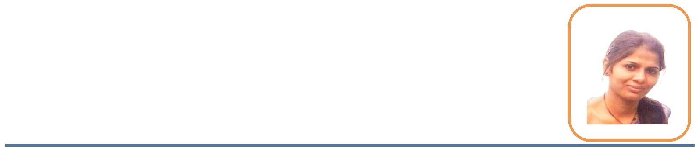

Tanu

Mobile No-09463321631 Email [Id:gtanu.20@gmail.com](mailto:gtanu.20@gmail.com)

|  |  |  |  |
| --- | --- | --- | --- |
| **ACADEMIC QUALIFICATION** | | | |
| **Year** | **Course** | **Name of Board/University** | **%age** |
| Jan,2015 | M.E CSE | Chandigarh University | 84 |
| 2012 | B.Tech | Lovely Professional University | 74.48 |
| 2008 | XII | C.B.S.E | 70 |
| 2006 | X | C.B.S.E | 78 |

# CORE TECHNICAL COMPETENCIES

* Six months experience in project development.
* Quick Learner and People person.
* Excellent Events Organizing skills and team player.
* Excellent Time Management and communication skills.
* Dedicated, committed, responsible and hardworking.

# TRAINING

**Organization**: Tech Mahindra Ltd, Noida

* **Duration**:- th

4

▪

july 2011 to 9th

dec 2011

**Project title**:- Courier Management System and also worked on TNID and UPID(various irrigation departments sites of Uttar Pradesh and Tamil Naidu)

▪

**Roles & Responsibilities:-** Software Testing and R&D Trainee

# MAJOR PROJECTS/ASSIGNMENTS

* *Major B.E Project*

✓

PROJECT 1: Successfully completed Visual BASIC



**Project Name: Courier Management System**

|  |  |
| --- | --- |
| **Company** | Tech Mahindra Ltd, Noida |
| **Tools used** | .NET |
| **Programming Language** | .NET USING C# |
| **Team Size** | 2 |
| **Platform** | Windows, Mac, Linux |
| **Description** | Worked on the live project of the company i.e TNID and UPID AND developed a |
| setup for the courier management system which can make the work easier |

# TWO MONTHS TRAINING

* **Organization:** C.S InfoTech, Chandigarh

30

# Period: th

5

June 2010 to th

july 2010

* **Worked on Technology:** .NET using C #
* **Role:** Trainee

# Techniques for analyzing the Color and the Quality of fruits Gulshan Goyal

* + *M.E Research project May2012-Dec 2012*

The project aimed to recognize color of fruit mainly apple in MATLAB. Different values of classified on the basis of hue values and named as a riot apple or not

**Tries as an application for autocomplete Amritpal Singh**

* + *M.E Research project Jan2013-Jun2013*

This project aims to get faster and efficient searching as one does in google.once we have save the word and will get the required result that required

# To detect areas using segmentation and performing compression Anju Shree

* *M.E Research Project July2013-Dec2013*

This Project aims to detect areas mainly the urban areas and compress it so that it takes very a little space to store it.

# COMPUTER SKILLS

* **Programming Languages:** C, C++and HTML.
* **Digital Image Processing**

**CONFERENCES/WORKSHOPS ATTENDED**

* Attended the “MICROSOFT” Workshop for 1 day in college
* Attended the Seminar on “RESEARCH METHDOLOGIES” for 1 day in college
* Visited the company Tech Mahindra ltd, noida and had six months training there
* Presented a Research Paper at ”NATIONAL CONFERENCE” Held at Chandigarh University
* Presented a Paper on” Terrain Separation of Urban area land using Image compression” in “INTERNATIONAL CONFERENCE OF COMPUTING AND MODELLING” Held at bbau, LUCKNOW
* Published a Paper in “ INTERNATIONAL CONFERENCE ON COMPUTER SCIENCE EDUCATION: INNOVATION AND TECHNOLOGY” held at Singapore 2014
* Published a paper in “INTERNATIONAL JOURNAL OF COMPUTER APPLICATION AND TECHNOLOGY (IJCAT) Held on September 2014
* Published a paper in “INTERNATIONAL JOURNAL OF INFORMATION AND EDUCATION TECHNOLOGY (IJIET).

# RELEVANT COURSES

* Computer Science: Digital Image Analysis, Computer Networks, Operating Systems, Theory of Computation, Analysis and Design of Algorithms, Programming Languages, Digital Hardware Design, Computer Architecture, Discrete Mathematical structure
* Data Structure